ALLERTON
CONGREGATIONAL CHURCH

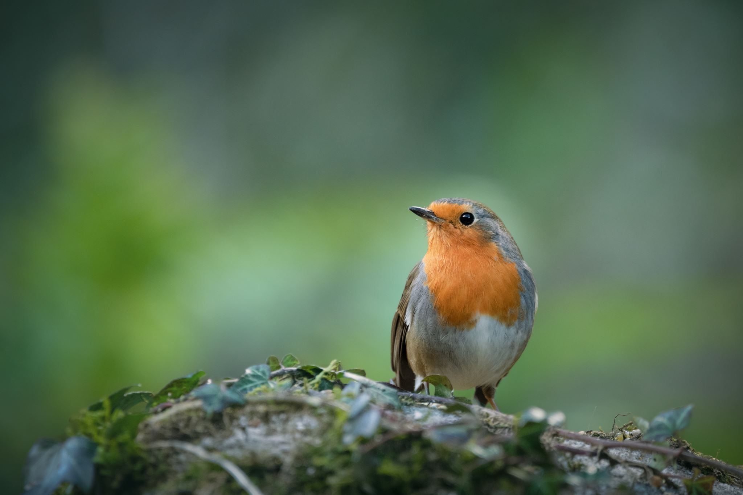

January/February 2026 Newsletter
Dear Friends
At the end of one year and the beginning of the next I’m never too sure if we should be looking back or looking forward. Either way I’m sure there’ll be plenty of reflections in the media of what took place in 2025 and what the hopes are for 2026.
As ever through the season of Advent we considered the words of the prophets who looked forward with great hope. Centuries before the birth of Jesus they predicted the coming of a future King and looked forward to better times ahead. Some of the prophesies are uncannily accurate, centuries before the birth of Jesus, Isaiah said, “The Lord himself will give you a sign; a young woman who is pregnant will have a son and will name him Immanuel” and later “A child is born to us a son is given to us and he will be our ruler”. Micah speaks of God bringing a ruler out of Bethlehem whose family line goes back to ancient times. These are not just prophesies they are words of hope for better times to come.
Looking forward can be a positive experience as the prophets of the Old Testament proved and being a positive person myself, I can subscribe to that. However, I’m not foolish enough to think that next year nothing will go wrong or that the wrongs in the world will be put right but I do believe that with God by our side there is every reason to be positive about the future. Not everyone will see it that way and I accept that, but we need to have hope that God has a plan for us and little by little his plan will be revealed.
Remarkably I still have the notes I wrote in the newsletter in December 2007 at the end of my first year with you and in it I said this “Christian hope has not changed down the centuries, it is not a doubtful kind of expectancy that hopes against hope, but a confident expectancy, a believing kind of hope based on a God who loves us and provides for us, a God who teaches us care, consideration, peace, co-operation, understanding and compassion”.
I still believe they are the hallmarks of a better future. I believe too that God has us in the palm of his hand and what lies ahead for us as individuals and as a church can be positive and exciting. As we travel into the New Year together let’s take that air of positivity with us, trusting God in all things and moving forward in hope and expectation with him.
Happy New Year
With every blessing Trevor

Finance/Property Report
The Finance Committee have been planning for some works in January 2026 which hopefully will see repairs to
the main hall windows, upgrade of the Noticeboard and the installation of a new banner to replace what has
become a rather tired 2014 banner.
Consideration is also in hand to freshen up the vestibule including redecoration and improved lighting, so as
they say “watch this space” for New Year improvements.
Happy New Year to all Members.
Christopher Ing Financial Secretary
Dates for your Diary 2026
Fri 2 January 26 1pm – Ladies Circle Meeting
Wed 14 January 26 10am - Church Planning Group Meeting.

Flower Rota – flowers provided by:
On Sundays not listed, silk flowers will be used

January 2026 |  |  | February 2026
4th | Mr & Mrs B Haley |  | 1st | Mr & Mrs R Hardy
11th |  |  | 8th | Mr & Mrs T Hippey
18th |  |  | 15th
25th | Mrs C North |  | 22nd | In memory of Mary & Denis Cockcroft

Preaching list
January 2026 |  |  | February 2026
4th | Trevor Kershaw |  | 1st | David Muschamp
11th | Rev Clive Barrett |  | 8th | Trevor Kershaw
18th | Trevor Kershaw |  | 15th
25th | Robert Waddington |  | 25th | Janice Le Blancq

Coffee Rota

It would be really helpful if those on the rota could come a little earlier to set things up. You will not need to bring milk.

Note from the Editor

The next newsletter is due on 1st March 2026 – please let me have any items for inclusion by 20th February 2026. Earlier dates due to Christmas.

Thank you Carole

Sundays - Services at 10.30 am.

Addresses:

Pastor | Treasurer | Secretary | Editor
Trevor Kershaw |  |  | Carole Brook
Mobile:
07811 888348

Website: allertoncongregationalchurch.org.uk
 facebook.com/allertoncongregationalchurch

