|  |
| --- |
|  |
| ALLERTON  CONGREGATIONAL CHURCH |

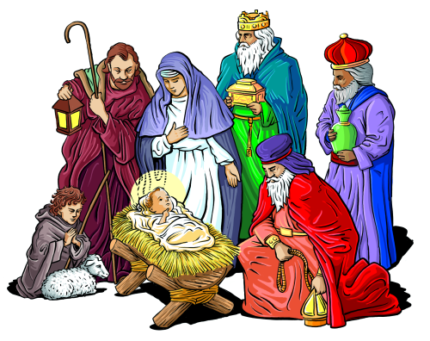

Merry Christmas Everyone

Dec ’18/Jan ‘19 Newsletter

Dear Friends

I have a confession to make: I dislike Christmas! No, actually I hate it with a passion! Let me tell you why. Many Christians will lament the commercialisation of the season with shops selling Christmas cards and mince pies earlier and earlier each year. They have a point, but it’s not that as such that bothers me. Neither is it the creep of calling it the Holiday season rather than Christmas, however real or imagined that trend might be. No, rather my concern is the relatively superficial way in which many in the church treat Christmas, the nativity and first coming of Jesus.

From the early part of December many churches seem to abandon sermons, Bible studies and careful reflection on the Scriptures. Instead the focus is on having the right carols and candles, and trotting out the good old cliches about putting Christ into Christmas without necessarily carrying that through. So what do I think our focus should be at this time of year? Well, one great place to start is the incarnation.

The late Eugene Peterson, in his Bible translation, The Message, puts John 1:14 like this:

   “The Word became flesh and blood, and moved into the neighbourhood.”

For me this sums up exactly what the incarnation is all about. This is how God decided to come into the world to sort out the problems of sin and death. Jesus came down from being with the Father to be born of Mary here on earth. He spent 9 months in the womb of a young girl before being born and laid in a cattle feeding trough, undoubtedly screaming (contrary to the false impression ‘Away in a manger’ gives us!)

If it had been down to us how might we have sorted out the problem of sin? Send down a divine version of the Magnificent Seven (or some other hero from the Westerns of yore) to zap all sin away? Have God’s voice ring out words of warning and judgment for everyone to hear at the same time? Whatever ideas we might have I suspect sending a baby into poverty somewhere in the back of beyond probably wouldn’t have been it. Yet, that is exactly what our God, the Creator of the heavens and the earth, and everything in them, did!

That is the incarnation and Christmas should, I think, be about our reflecting on this central truth and its significance to us. It tells us first of all that God cares about us enough to come and live here with us, going through everything that we go through. He moved into our neighbourhood and got stuck in, giving us a solution to sin and death. He was tempted in every way, as we are, and yet was without sin. His life led to His death for us, and of course, paid the price for our wrongs that we might be adopted into God’s family, and in effect move into God’s neighbourhood.

Just as Jesus got involved and lived life in the real world that He created, so we are to also get involved. Jesus is the most amazing example of how our Heavenly Father wants us to live as His people, getting our hands dirty in the worst neighbourhoods of our towns and cities, as well as the more pleasant ones too. Bringing His light into dark neighbourhoods of our world.

Graham Kendrick wrote, “This is our God, the Servant King; He calls us now to follow Him, to live our lives as a daily offering of worship to the Servant King.” Kendrick has grasped the importance of God coming to earth, as a servant, sorting things out and calling us to be like Jesus. This is the Christmas message that can truly have a massive impact on us, our churches and our world. So this year why not be Christ in the midst of all the Christmas activities and events, rather than keeping the Christ in Christmas!

Yours, Fred.

Pulpit

December 2nd Rev Fred Rich Communion Service

December 9th Trevor Kershaw

December 16th Rev Fred Rich Carol Service @ 10.30am

Christingle Service @ 4pm

December 23rd Trevor Hippey

December 25th Rev Fred Rich Christmas Day Service

December 30th Rev David Muschamp

January 6th 2019 Rev Fred Rich Communion

January 13th Rev David Muschamp

January 20th Trevor Hippey

January 27th Rev Fred Rich

Collection

November 4th £108.30

November 11th £200.81

November 18th £ 97.90

November 25th £143.34

Flowers

We are very grateful to the following friends who have kindly promised to provide flowers the plants for December 2018 and the flowers for January 2019.

December Mrs E Smith

January 6th 2019 Mrs Hume

January 13th Mr & Mrs B Haley

January 20th Mrs North

January 27th Mrs Snowden

Mrs S Hardy & Miss F Hardy will be responsible for arranging and distributing the flowers throughout this January.

Ladies Circle

The next Ladies Circle meeting will be held on December 5th in the form of the annual Christmas party. This year the ladies are donating selection boxes for young carers supported by Barnardo’s. Could you please bring them to church no later than December 16th. Thank you, Carole.

Christmas Cards

Instead of sending out the usual many, many Christmas Cards this year, Chris and Sue will be sending a donation to the Leprosy Mission. Might save a few trees as well, which is also a good thing.

We wish you all a Merry Christmas and a happy and peaceful New Year.

Love from Chris and Sue

Week of Prayer for Christian Unity

Week of Prayer for Christian Unity 2019 will be held between January 18-25th . The following churches are hosting the meetings:

Friday 18th Allerton Methodist Church

Tuesday 22nd Allerton Congregational Church

Wednesday 23rd St Saviours

Thursday 24th Bethal Baptist Church

In the absence of any other information, the meetings will probably start at 12noon.



Every Sunday Family Service 10.30am

Contacts:

Pastor: Secretary & Treasurer: Editor: Fredrik Rich Janet & David Muschamp Faye Hardy

## Website: allertoncongregationalchurch.org.uk

 **facebook.com/allertoncongregationalchurc**

